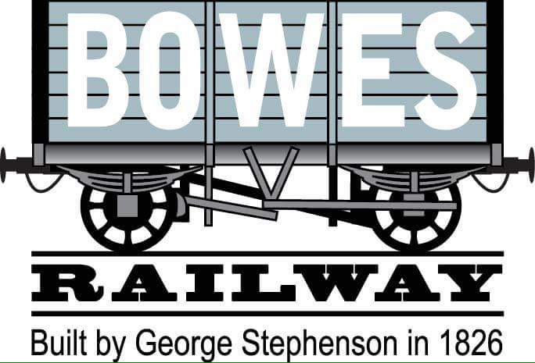
The Bowes railway was built to move coal, from the mines in the West of Durham, passing various pits to the coast at Jarrow. It was built by the Grand Allies to connect their Springwell & Mount Moor collieries with the Jarrow staiths. They handed the project to colliery engine wright George Stephenson who designed the railway with three rope hauled incline and a locomotive worked section, with two very early steam engines.
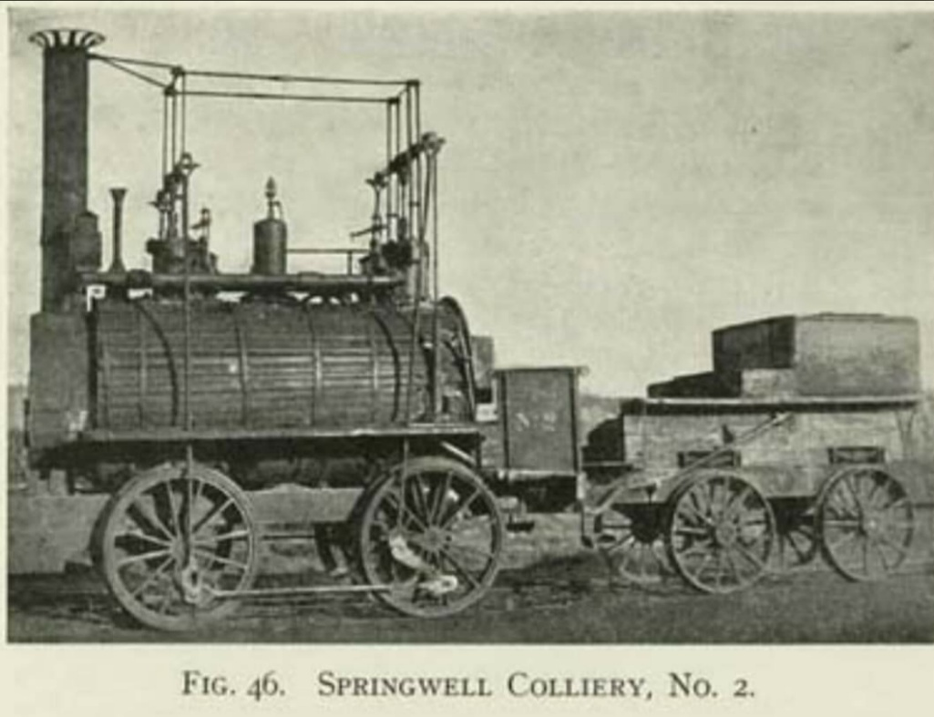
The line opened on 17th January 1826 and was later extended to Kibblesworth in 1842, Marley Hill in 1853 and Dipton in 1855. The line continued to operate in the same methods using six inclines (two gravity worked and four powered inclines) and two locomotive worked sections at either end of the railway. Springwell colliery closed in 1932 and the colliery buildings were converted into the railway workshops after this date, these form the basis of our museum. Also in 1932 the line changed its name from the Pontop & Jarrow railway to the Bowes railway.

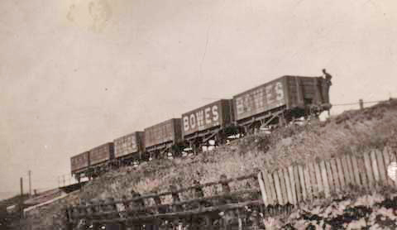
From 1947 the line became part of the National Coal Board, this saw investment in the railway, such as replacing the aging steam winding engines with modern electric haulers. The neighbouring Pelaw Main railway was linked to the Bowes railway in 1955 (surviving the mines at Ravensworth, Team Valley and Ouston). The line closed beyond Kibblesworth in 1969 with Kibblesworth now being the only colliery sending its coal via the Bowes railway. The closure of Kibblesworth pit on the 4th October 1974 brought to an end most operations, with closure finally coming in November 1974.
The final section of the line remained between Springwell Bankfoot and Jarrow Staiths was used as the Monkton railways – this served a coal washery but the final rail traffic on this remaining section was on the 10th January 1986 when it was closed by the National Coal Board, leaving only the preserved sections of the railway in operation.
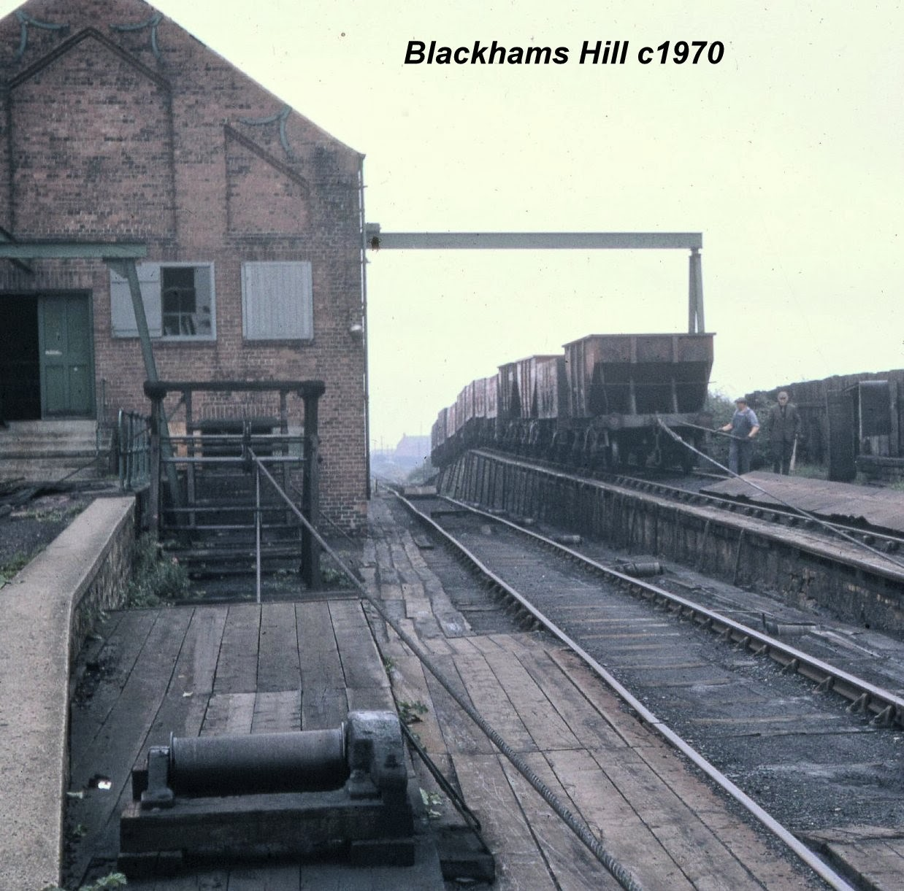
The 1½ mile section between Black Fell and Springwell was saved by Tyne and Wear County Council as well as the Springwell workshops and 40 wagons from the railways fleet were saved for the nation. The site preserved three original locomotives for use as well as demonstrating the two remaining inclines. The railway was later made a scheduled ancient monument, the preserved workshops later helped build a replica of Stephenson’s rocket. In 1979 the Pelaw Main spur was re-laid for passenger use and finally in 2002 the site was granted museum status.

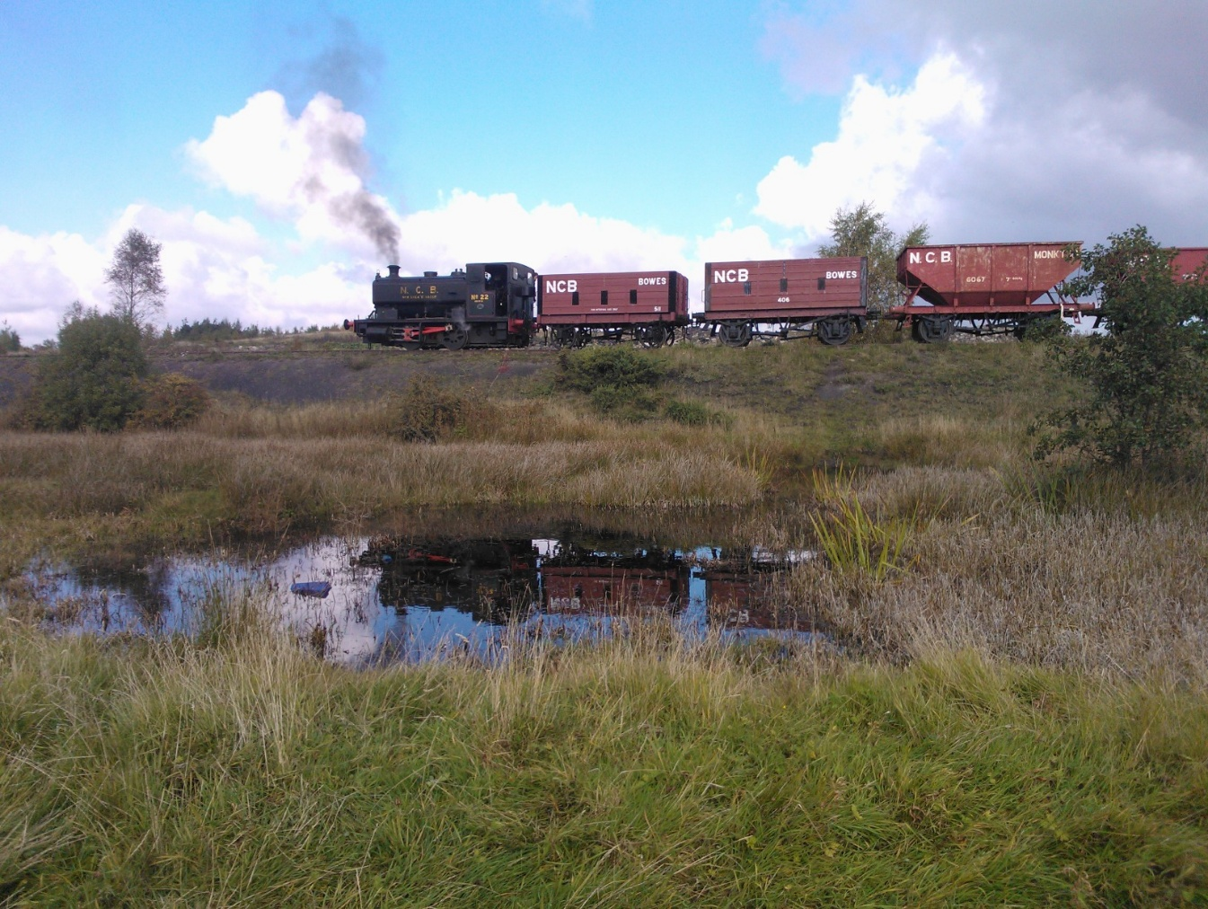
The railway is now a museum, with community events such as Springwell 1940’s weekend, a cafe, preserved Victorian workshops, the world’s only standard gauge rope hauled inclines and a mile long passenger railway. For more information visit us on: http://bowesrailway.uk or https://m.facebook.com/bowesrailway/

